Supply Base Report: PUSBROLIAI UAB

First Surveillance Audit

www.sbp-cert.org

Completed in accordance with the Supply Base Report Template Version 1.3

For further information on the SBP Framework and to view the full set of documentation see www.sbp-cert.org

Document history
Version 1.0: published 26 March 2015
Version 1.1 published 22 February 2016
Version 1.2 published 23 June 2016
Version 1.3 published 14 January 2019; re-published 3 April 2020

© Copyright Sustainable Biomass Program Limited 2020

Contents
1 Overview 1
2 Description of the Supply Base 2
2.1 General description 2
2.2 Actions taken to promote certification amongst feedstock supplier 2
2.3 Final harvest sampling programme 2
2.4 Flow diagram of feedstock inputs showing feedstock type [optional] 2
2.5 Quantification of the Supply Base 2
3 Requirement for a Supply Base Evaluation 5
4 Supply Base Evaluation 6
4.1 Scope 6
4.2 Justification 6
4.3 Results of Risk Assessment 6
4.4 Results of Supplier Verification Programme 6
4.5 Conclusion 6
5 Supply Base Evaluation Process 7
6 Stakeholder Consultation 8
6.1 Response to stakeholder comments 8
7 Overview of Initial Assessment of Risk 9
8 Supplier Verification Programme 10
8.1 Description of the Supplier Verification Programme 10
8.2 Site visits 10
8.3 Conclusions from the Supplier Verification Programme 10
9 Mitigation Measures 11
9.1 Mitigation measures 11
9.2 Monitoring and outcomes 11
10 Detailed Findings for Indicators 12
11 Review of Report 13
11.1 Peer review 13
11.2 Public or additional reviews 13
12 Approval of Report 14
13 Updates 15
13.1 Significant changes in the Supply Base 15
13.2 Effectiveness of previous mitigation measures 15
13.3 New risk ratings and mitigation measures 15
13.4 Actual figures for feedstock over the previous 12 months 15
13.5 Projected figures for feedstock over the next 12 months 15

Overview
On the first page include the following information:
Producer name: PUSBROLIAI UAB
Producer location: Silutes pl. 2-510, LT-91111 Klaipeda, Lithuania
Geographic position: 55.703563, 21.162145
Primary contact: Rūta Gaber – Feedstock supply specialist, ruta@pusbroliai.eu +370 655 13365
Company website: https://pusbroliai.eu/
Date report finalised: 18/08/2020
Close of last CB audit: 01/10/2019, Klaipeda
Name of CB: NEPCon UAB
Translations from English: No
SBP Standard(s) used: SBP Standard 1 V1.0;; SBP Standard 2 V1.0;; SBP Standard 4 V1.0;;
SBP Standard 5 V1.0 (instructions documents 5A V1.1;; 5B V1.1;; 5C V1.1)
Weblink to Standard(s) used: https://sbp-cert.org/documents/standards-documents/standards
SBP Endorsed Regional Risk Assessment: https://sbp-cert.org/wp-content/uploads/2019/06/SBP- Regional-Risk-Assessment-for-Lithuania-Jun-16.pdf
Weblink to SBE on Company website: https://pusbroliai.eu/biokuras/

Indicate how the current evaluation fits within the cycle of Supply Base Evaluations
Main (Initial)  Evaluation | First  Surveillance | Second Surveillance | Third  Surveillance | Fourth  Surveillance
☐ | √ | ☐ | ☐ | ☐

Description of the Supply Base

General description
Pusbroliai UAB specialised in the sales and production of biomass – wood chips. The feedstock is sourced from Lithuanian suppliers including state forests and forests form owners, areas outside forests (overgrown agricultural areas, powerline, ditch areas, branches after clearing, sides of the roads), forestry products intermediaries. The primary feedstock comes from firewood, timber offcuts, branches and barks as wood residues from forests, old palets as post-consumer material. About 50 % of the primary wood chips is produced in areas outside forests as clearing of trees and shrubs. As Secondary Feedstock company purchases sawdust, bark and other wood residual from sawmills.
Lithuanian state forests are well organized and all of them are certified according to FSC. Around 50 % each year of the primary feedstock comes from certified forests.
Also the regions of primary material are Lithuania – 100 % All material is purchased with FSC.
Data from deliveries period: From 1 October 2019 till 31 September 2020

Controlled Feedstock:
SBP-compliant Primary Feedstock: 94% ( ~16 suppliers, as FSC 100%)
SBP-controlled Primary Feedstock: 0%
SBP-compliant Secondary Feedstock: Chips 6% (~1 supplier, as FSC 100%)
SBP-compliant Secondary Feedstock: Sawdust, barks 0%
SBP-controlled Secondary Feedstock: 0%
SBP-compliant Tertiary Feedstock: 0% Post consumer old palets (Post consumer)
SBP non-compliant Feedstock: 0%
Generic: Picea abies (L.) H. Karst.; Pinus sylvestris L.; Alnus glutinosa (L.) Gaertn.; Alnus incana (L.) Moench; Populus tremula (L.); Betula pendula (Roth); Betula pubescens (Ehrh.).
Actions taken to promote certification amongst feedstock suppliers.
LITHUANIA’S forest resources

Agricultural land covers more than 50 % of Lithuania. The forested land occupies about 28 % or 2.18 million
ha, while the land classified as forest occupies about 30 % of the total land area. The south-eastern part of the country is most heavily forested, and here forests cover about 45 % of the land. The total land area belonged to the State forest enterprises is divided into forest and non-forest land. Forest land is divided into forested and non- forested land. The total value added in the forestry sector (including manufacture of furniture) reached LTL 4.9 billion in 2013 and was 10 % higher than in 2012.

Approximately a half of forest land in Lithuania is owned by the State and managed by 26 regional divisions of State Forest Enterprise and the Directorate General of State Forests. Respectively, around 40 % of forest land is privately owned and the rest 10 % is still reserved for restitution.

All types of cuttings are prohibited in reserves. Clear cuttings are prohibited in national parks, while thinning and sanitary cuttings are allowed there. Clear cutting is permitted, however, with certain restrictions, in protected forests; and thinning as well. Almost no restrictions as to logging methods exist in the forests of commercial category.

Lithuania has signed the CITES Convention in 2001. CITES requirements are respected in forest management, although there are no species included in the CITES lists in Lithuania.

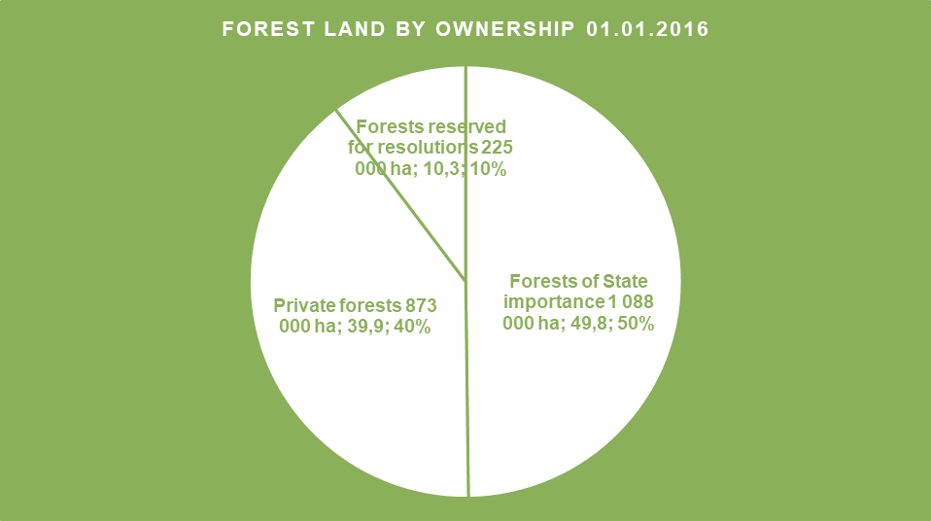
1 chart. Forest land by ownership. Source: Lithuanian State Forest Service

Lithuania is situated within the so-called mixed forest belt with a high percentage of broadleaves and mixed conifer-broadleaved stands. Most of the forests – especially spruce and birch – often grow in mixed stands. Pine forests are the most common type of forests, covering about 38 % of the woodland. Spruce and birch forests account for 24 % and 20 % respectively. Alder forests occupy about 12 % of the forest area, which is a relatively high figure that indicates the moisture level on specific sites. Oak and ash account for about 2 % of the forest area each. The area occupied by aspen stands is almost 3 %.

The growing stock in Lithuanian forests is about 180 m3 per hectare. In nature stands, the average growing stock in all Lithuanian forests is 244 m3 per hectare. Total annual growth is almost 11,900,000 m3 and the average annual wood increase has reached 6.3 m3 per hectare.

The expected annual logging volume is 5.2 million m3, 2.4 million m3 of which are sawn wood and the remaining 2.8 million m3 are small dimension wood for production of paper pulp or boards or for using as firewood. The calculations refer to the nearest 10-year period. If more intensive and efficient forest management systems are implemented, successful growth should be achieved.

Sustainable forest management is the overriding objective for forest policy and practise in Lithuania. Certification of all State forests in Lithuania is performed according to the strictest certification system in the world – the FSC (Forest Stewardship Council) certificate. The audit of this certification confirms the fact that Lithuanian State forests are managed responsibly, in compliance with the requirements of protection and conservation of biodiversity. Therefore, forest resources are used responsibly and annual timber harvest rate does not exceed the annual increment. Lithuania’s forests produce around 18 million m3 of stem wood (over bark). Annual fellings do not exceed 60 per cent of gross total annual increment. In May 2019 total FSC Certified Forest Area in Lithuania was 1,170,683 hectares and 349 Chain of Custody Certificates. (FSC Facts & Figures, May 6, 2019).

Sources:
http://www.fao.org/3/w3722e/w3722e22.htm#TopOfPage
http://www.amvmt.lt/images/veikla/stat/miskustatistika/2016/02%20Misku%20ukio%20statistika%202016_m.pdf
FSC Facts & Figures, May 6, 2019

LATVIA’S forest resources
Latvia has the fourth highest forest cover among all EU countries, surpassed only by Finland (77 %), Sweden (76 %) and Slovenia (63 %). Forests in Latvia take up 3.412 million hectares of land, or 53% of the country’s territory. The Latvian state owns around one-half of the country’s forests, while most of the rest of the forest belongs to approximately 135,000 private owners. The amount of forestland, moreover, is constantly expanding, both naturally and thanks to afforestation of infertile land and other land that is not used for agriculture.
In 2019, the predominant forest species in Latvia are: Pine 33%, Birch 30 %, Spruce 19%, Grey Alder 7%, Aspen 7%, Black Alder 3 %, Other Species 1%. (State Forest Service data in Latvian Forest Sector in Facts & Figures 2020, published by the Ministry of Agriculture: https://www.zm.gov.lv/public/ck/files/ZM/mezhi/skaitlifakti_ENG20.pdf)
An average of approximately 11 million m3 of timber have been harvested each year in Latvia’s forests during the past decade. That is less than the annual increment, and so forestry in Latvia can be described as sustainable. (State Forest Service data in Latvian Forest Sector in Facts & Figures 2020, published by the Ministry of Agriculture: https://www.zm.gov.lv/public/ck/files/ZM/mezhi/skaitlifakti_ENG20.pdf)
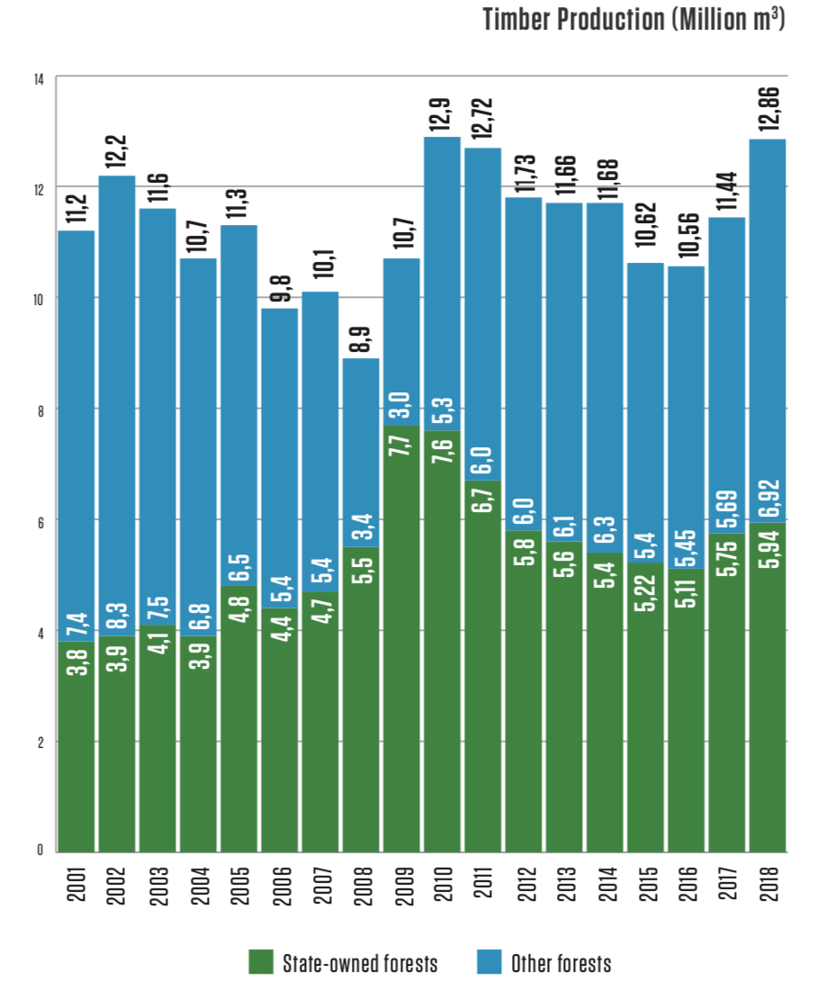
Ownership
The Latvian state owns around one-half of the country’s forests, while most of the rest of the forest belongs to approximately 135,000 private owners. Forest ownership by status, 2019 (State Forest Service).
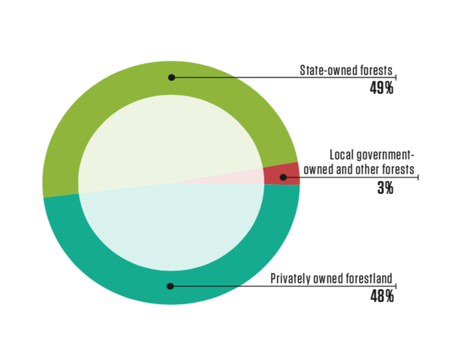

Management practices
The forest sector in Latvia is under the supervision of the Ministry of Agriculture. It works with stakeholders to draft forest policies, development strategies for the sector, as well as regulations on forest management, the use of forest resources, environment protection and hunting. www.zm.gov.lv. The State Forest Service, under the Ministry of Agriculture, is the responsible agency for supervising how the provisions of the laws and regulations are observed in forest management irrespective of the ownership type. www.vmd.gov.lv. State-owned forests are managed by Stock Company “Latvian State Forests”, which was established in 1999. It implements the state’s interests in terms of preserving and increasing the value of the forest and enhancing the contributions of the forest to the national economy.
Limitations on economic activity apply to 28,2% of Latvia’s forests at this time, and most of this territory is owned by the state. 683 especially protected environmental territories have been set aside to protect nature. Many are included in the unified and pan-European NATURA 2000 network of protected territories.
There are various restrictions on economic activity in the specially protected areas, ranging from a complete ban on forestry throughout the calendar year to a ban on tree felling in certain months of the year or on specific conditions for felling. Overall, in around 13.5% of Latvia’s forests there are some form of forest management restrictions in place, in 3.4% of these areas all forest management activities are prohibited.
Due to the dramatic increase in forest cover in the last 100 years, the current proportion of old-growth forests in Latvia is low and as such, a major challenge of forest conservation in Latvia is to ensure that such old- growth forests and features are protected and allowed to develop. www.lvm.lv
According to the State Forest Service data, the total growing stock volume was 682 million m3 in 2019. Latvian forest land consists of:
Forest land consists of:
- Forests 3.04 mln. ha (90.6%);
- Marshes 0.17 mln. ha (5.1%);
- Glades 0.031 mln. ha (0.9%);
- Flooded areas 0.017 mln. ha (0.5%);
- Objects of infrastructure 0.081 mln. ha (2.4%);
- Other forest land 0.017 mln. ha (0.5%).
State Forest Services: vmd.gov.lv, 2019.
The field of forestry
In Latvia, the field of forestry is supervised by the Ministry of Agriculture, which in cooperation with stakeholders of the sphere develops forest policy, development strategy of the field, as well as drafts of legislative acts concerning forest management, use of forest resources, nature protection and hunting (www.zm.gov.lv). Implementation of requirements of the national law and regulations notwithstanding the type of tenure is carried out by the State Forest Service under the Ministry of Agriculture (State Forest Services: www.vmd.gov.lv). Management of the state-owned forests is performed by the Joint Stock Company “Latvia’s State Forests”, established in 1999. The enterprise ensures implementation of the best interests of the state by preserving value of the forest and increasing the share of forest in the national economy (www.lvm.lv).
Export yielded 2,645 billion euro (approx. 21% of all exports in 2018).
Socio-Economic setting
According to the Latvian Ministry of Agriculture, the forest sector is one of the cornerstones of the national economy at this time. Forestry, wood processing and furniture manufacturing represented 5,1% of GDP in 2018, while exports amounted to EUR 2,645 billion – 21% of all exports. There is no parish in Latvia with no larger or smaller wood processing company. Often these are the most important employers in the surrounding area, thus being the main pillar of support for local economies and residents.
The forest industry has always been Latvia’s export leader. About 71 % of forestry-sector output is exported. The foreign trade balance of the Latvian woodworking industry is positive, having reached EUR 1.7 billion in 2018. In 2018, the value of forest product exports was EUR 2.645 billion, 17 % higher than in 2017, while the value of forest products import was EUR 939 million. The main export destinations traditionally are the EU countries: the United Kingdom, Germany, and Sweden that together account for more than 40% of Latvia’s wooden product exports.
Biological diversity
In historical terms, the intensive use of Latvia’s forests for economic purposes began comparatively later than in many other European countries, and that has allowed us to preserve extensive biological diversity. Limitations on economic activity apply to 28,2% of Latvia’s forests at this time, and most of this territory is owned by the state. 683 especially protected environmental territories have been set aside to protect nature. Many are included in the unified and pan-European NATURA 2000 network of protected territories.
In order to protect highly endangered species and biotopes located without the designated protected areas, if a functional zone does not provide that, micro-reserves are established. In 2018, the State Forest Service has established and maintained 2417 micro-reserves in forest lands with a total area of 43.7 thousand. ha, of which 91% of micro-restricted areas are in state forests, 7% - in private forests and 2% - in municipal forests. Identification and protection planning of biologically valuable forest stands is carried out continuously.
Moreover, there are national laws in place designed for the preservation of biological diversity and general nature protection requirements must be followed during the forest management activities. These are binding to all forest managers. These requirements stipulate that selected old and large trees, dead wood, underwood trees and shrubs, land cover around wet micro-lowlands (terrain depressions) are to be preserved at felling, thus providing habitat for many organisms.
Latvia has been a signatory of the CITES Convention since 1997. CITES requirements are respected in forest management, although there are no species included in the CITES lists in Latvia.
Forest and community
Areas where recreation is one of the main forest management objectives add up to 8 % of the total forest area or 272 960 ha (2019). Observation towers, educational trails, natural objects of culture history value, picnic venues: they are just a few of recreational infrastructure objects available to everyone free of charge. Special attention is devoted to creation of such areas in state-owned forests. Recreational forest areas include national parks (excluding strictly protected areas), nature parks, protected landscape areas, protected dendrological objects, protected geological and geomorphologic objects, nature parks of local significance, the Baltic Sea dune protection zone, protective zones around cities and towns, forests within administrative territory of cities and towns. Management and governance of specially protected natural areas in Latvia is co-ordinated by the Nature Conservation Agency under the Ministry for Environmental Protection and Regional Development.
Certification
All forest area of Latvijas Valsts Meži as well as some part of forests in private and other ownership are FSC or PEFC certified. From a total forest area of 3.412 million hectares more than a hald of Latvian forest ares have been certified according to FSC or PEFC certification scheme. Both the FSC and PEFC systems have found their way into Latvia.

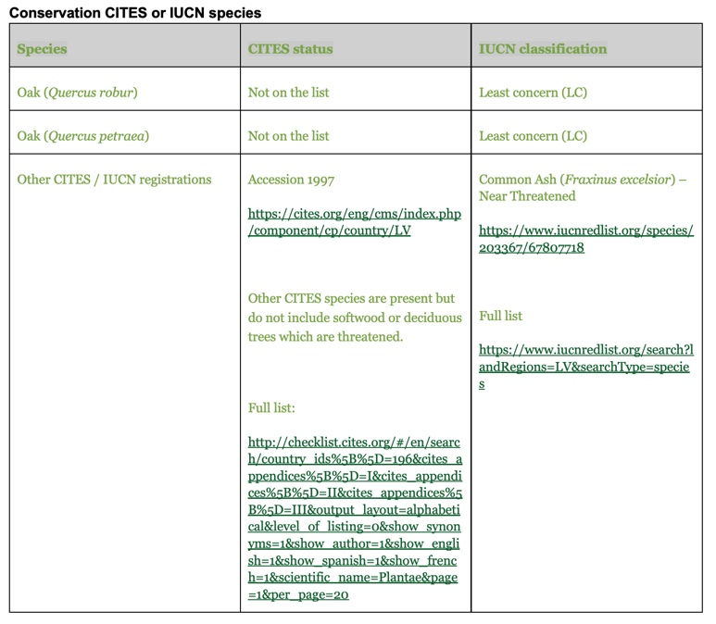
Belarus forest resources
All forests in Belarus are in exclusive property of the State. The total area of forest fund is 9,582 million ha of which 8,26 million ha are covered by forest lands. The percentage of forest cover in Belarus reached 39,8%. The total stock of timber is 1796 million m3, including ripe and overripe stands which comprise over 296 million m3.
As a result of conscious efforts on forests’ reproduction, during the last 60 years the area covered by forest has doubled and reached its highest value for more than 100-year period. This increase is a result of both natural processes and afforestation of barren lands unsuitable for farming industry. In Belarus along with increase of total area of forest lands, one could witness a sustainable growth of ripening, ripe and overripe stands. The share of ripe and overripe forests is 14,7%. Average age of stands is over 56 years.
In Belarus the main principles of forest managements are based on the following regulatory documents:
- State-run program for 2016-2020 “Belarus forest”
- National strategy on sustainable development of the Republic of Belarus
- Forest Code of the Republic of Belarus.
28 tree species and about 70 species of bushes grow in Belarus. The most widespread are: Scots pine - 50.3%, Birch - 23.2%, European spruce - 9.2%, Black alder - 8.5%, Oak - 3.4%, Aspen - 2.1%
There are two types of forest lands depending on accomplished functions: first and second groups. The first group comprises specially protected nature conservation areas (about 52%), and the second one – exploitable forests for timber harvesting (48%). In accordance with the legislation of the Republic of Belarus all forest lands are in state property and assigned to state forestry enterprises for use. The forest use in Belarus is based on the principle of continuity and sustainability.
Average annual timber harvesting value is about 18 million m3, which include:
- final felling (mature timber) – 40%
- cleaning cuttings and sanitary felling (young, middle-aged and ripening stands – 48%)
- other cuttings – 12%.
The main conditions of forests’ exploitation are the procurement of forest reproduction and protective afforestation. In 2018 the forest reproduction and afforestation were carried out at the total area of 41,82 thousand ha, including such measures as planting of new forests (about 34,8 thousand ha).
According to the forest legislation of the Republic of Belarus, the endangered species and the places of their habitation included in the Red List are to be protected during timber harvesting processes. In the supply
base CITES do not grow. The cutting of valuable, endangered and specially protected tree species is strictly prohibited.
There are two preserved areas at the territory of Republic of Belarus
- Berezinsky Biosphere Reserve (85.2 thousand ha) and Polesie State Radioecological Reserve (216,1 thousand ha) and four national parks - Belovezhskaya Pushcha (152,962 thousand ha), Braslav Lakes (69,115 thousand ha), Narachanski National Park (93,3 thousand ha) and Pripyatsky National Park (85,841 thousand ha) as well as 334 forest Republic and local reserves and 874 monuments of nature.
The forest certification is an effective tool against illegal cuttings and illegal circulation of timber.
There two schemes of forest certification implemented in the Republic of Belarus: FSC (Forest Stewardship Council) and PEFC (Programme for the Endorsement of Forest Certification).
As of 1st of January 2019, 96 forest management units (98,5% of total forest fund that belongs to the Ministry of Forestry) is certified in accordance with the requirements of Forest Stewardship Council (FSC). 93 forest management units (95 % of total forest fund that belongs to the Ministry of Forestry) is certified in accordance with the requirements of PEFC (Programme for the Endorsement of Forest Certification).
In Belarus timber industry comprises of forest management (13,5%), processing of timber (69,5%) and paper-pulp industry 16,4%). Timber processing is one of the largest manufacturing sectors in Belarus Republic andhas a share of about 2% from the whole processing sector in Belarus Republic. Timber industry in Belarus в makes approximately 1,1% of gross domestic market. Timber-based products are exported to about 30 world countries.
Source: Ministry of Forestry of Republic of Belarus
PRB industry is engaged in the production of cylindrical products. Processing residues (wood chips and sawdust) are used for the production of wood pellets. Roundwood for main production comes from the sanitary felling in the forest fund of Belarus Republic.

Actions taken to promote certification amongst feedstock supplier
Pusbroliai UAB is purchasing about 50 % feedstock from suppliers who are certified by FSC and / or PEFC schemes to support the responsible forestry. Pusbroliai UAB informs suppliers about criteria and importance of FSC and PEFC certificates, as the industry requires more and more certification.
Pusbroliai UAB also is informing suppliers about SBP objectives and requirements and importance to comply with them. These documents promote legal and sustainable forest management, exclude timber from undefined sources and from Woodland Key Habitats (WKH). At the time, company increase amount of FSC­certified feedstock purchase as much possible.

Final harvest sampling programme
The proportion of final fellings which end up in biomass is about 20 % compared to other end uses. This information is derived from the documents and data submitted by suppliers and forest developers.

Flow diagram of feedstock inputs showing feedstock type
Certified and non-certified with SBP Supply Base Evaluation Primary feedstock:
Wood residue
-Forest
-Area outside forest
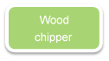
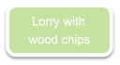
Heating plant
Firewood
Vessel
Timber lorry

Storage

Storage
Wood chipper
Lorry with wood chips

Certified and non-certified SBP Supply Base Evaluation Secondary and Tertiary feedstock:
-Forest
Producer
Roundwood

-Pallets, skids
-Wood Chips
-Sawdust, Bark

Storage
Lorry with Wood Chips / Sawdust

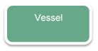
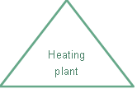

Quantification of the Supply Base
Supply Base

- Total Supply Base area (ha): Lithuania: 2,186,000 hectares of forest in total. The certified material, 60%, is primary sourced from FSC certified forest. 50% of the forest area in Lithuania is FSC certified. 40% of the material have a SBP-approved controlled feedstock system claim. Country of origin Lithuania. Latvia: 3,056,578 hectares of forest in total. Belarus: 8,260,000 ha. Total: 13,502,578 ha
- Tenure by type (ha): Lithuania: Privately owned (including companies): 873,000 hectares State forest: 1,313,000 hectares, Latvia: 2,650,000 ha – state forests, Belarus: 7,894,000 ha – state forests.
- Forest by type (ha): Temperate: 13,502,578 hectares
- Forest by management type (ha): Plantation/Managed natural: 13,502,578 hectares
- Certified forest by scheme (ha): FSC – 8,982,002 hectares
Feedstock

- Total volume of Feedstock: 0 – 300,000 tonnes
- -
- Volume of primary feedstock: 0 – 250,000 tonnes
- List percentage of primary feedstock (g), by the following categories. Subdivide by SBP-approved Forest Management Schemes:
  - 50% Certified to an SBP-approved Forest Management Scheme
  - 50% Not certified to an SBP-approved Forest Management Scheme
- List all species in primary feedstock, including scientific name: Picea abies (L.) H. Karst.; Pinus sylvestris L.; Alnus glutinosa (L.) Gaertn.; Alnus incana (L.) Moench; Populus tremula (L.); Betula pendula (Roth); Betula pubescens (Ehrh.).
- Volume of primary feedstock from primary forest: 0 tonnes
- List percentage of primary feedstock from primary forest (j), by the following categories. Subdivide by SBP-approved Forest Management Schemes:
  - Primary feedstock from primary forest certified to an SBP-approved Forest Management Scheme: 0%
  - Primary feedstock from primary forest not certified to an SBP-approved Forest Management Scheme: 0%
- Volume of secondary feedstock: specify origin and type - 10%
- Volume of tertiary feedstock: specify origin and composition - 0%

Requirement for a Supply Base Evaluation
SBE completed | SBE not completed
√ | ☐

The Supply Base Evaluation (SBE) is applicable for feedstock sourced in Lithuania. Because Pusbroliai UAB is buying from different sources, that are not all FSC certified and in order to produce SBP compliant wood chips from this supply base the SBE is necessary. There is thus of a supply base and this require a detailed evaluation to identify the risk, and to mitigate them.
SBP biomass supply evaluation includes:
- Primary feedstock (woodchips from firewood and branches as wood residues from logging);
- Primary Non-forest land feedstock (woodchips from overgrown agricultural areas, powerline and ditch areas branches after clearing, sides of roads);
- Secondary wood feedstock (chips, sawdust after processing).
The evalution process use the SBP endorsed risk assessment for Lithuania. The risk assessment is divided into: "Low risk" and "Defined risk"
SBP-endorsed Regional Risk Assessment for Lithuania

Supply Base Evaluation

Scope
In order to evaluate the risk level of all indicators of the SBP Framework Standard 1: Feedstock Compliance Standard, Pusbroliai UAB will carry out the SBE for primary and secondary feedstock that is originating from Lithuania:
-It applies to primary feedstock supplies as firewood and as wood residues from forest.
-It applies to primary feedstock suppliers from the overgrown agricultural land areas after clearing and other non-forest land.
-It applies to the secondary feedstock after round wood processing as wood residues (sawdust, bark and other wood residues) and as wood chips.

Justification
The basis of the provisions of agreements concluded by Pusbroliai UAB with biomass and wood buyers in 2020 is the supply of SBP-compliant products. Therefore, the decision of the company management is to design SBE risk minimisation measures and to implement the highest social and environmental standards, cooperate with suppliers, attract experts to exclude the purchase of wood that does not meet the SBP-certified product status.
SBP endorsed SBP Regional Risks Assessments have been developed in accordance with SBP standard Nr.1 version 1.0 of March 2015 and SBP standard Nr.2 version 1.0 of March 2015, assessing the risk category for Lithuania as well as for each SBP indicator. Through reviewing and assessing the risk, the company acquired an in-depth understanding of the wood supply risks that could affect the acceptance of SBP non-compliant material for biomass production.
The evalution process use the SBP endorsed risk assessment for Lithuania (specified risk is stated in the indicators 2.1.2, 2.8.1). Pusbroliai UAB agrees with all the findings, conclusions and mitigation measures set out in the reports for Lithuania.

Results of Risk Assessment
The risk assessment analysis includes the requirements provided by the laws and regulations of the Republic of Lithuania, regulatory activities of the State legislation and laws and regulations for primary and secondary wood supply from the Lithuania forest properties and protected areas.
Considering the specific character of Lithuania and expert advices and recommendations "Specified risk" was applied to:
2.1.2 – Potential threats to forests and other areas with high conservation values from forest management activities are identified and addressed (HCV category 3).
2.8.1 - Appropriate safeguards are put in place to protect the health and safety of forest workers.

Results of Supplier Verification Programme
SBP approved supplier audits and results described below and associated with specific risks are available to third parties and interested parties by documentary evidence of the audits performed.
The information obtained during risk assessment from both the legislative and the physical information verification on site on all SBE risk categories has confirmed that “Specific risk” are applicable to 2 categories: biotope protection (HCV category) and work safety, whereas the risk for other categories is low.
Risk evaluation and mitigation actions for primary feedstock about WKH can be done at the database and compliance with work safety demands shall be based on audits at forest management units. Secondary feedstock approval is possible only for that processors who have rough wood suppliers, which correspond to Risk mitigation requirements and who agreed to cooperate for the purpose of evaluation and mitigation of risks on their processing places before processing the wood.

Conclusion
Since Jun 1, 2020 when the requirements of SBE standards were initiated and introduced, the compliance of feedstock suppliers to specific risks was reviewed. Only a small part of suppliers who have direct logging and the competence to assess potential risks is recognized suitable as SBP suppliers for wood that is not certified according to the requirements of FSC or PEFC standards.
The amount of FSC or PEFC certified forests and access to certified wood is insufficient to ensure required volume of the biomass with SBP-compliant biomass status.
There is “low risk” to all indicators of the SBP standard 1 apart from two: 2.1.2, 2.8.1 in Lithiania based on the SBP-endorsed Regional Risk Assessment for Lithuania. In this document, there is an identification of the indicators with specified risk and clear risk mitigation measures to get these specified risk indicators down to low risk.
Pusbroliai UAB will get the overview to control and monitor the forest operations and meet SPB requirements together with procedure. Also, when company inspecting and performing risk mitigation measures to his supplier before logging in certain production area, can be if risk mitigation measures are effective and meet SBE low risk category at supply level.

Supply Base Evaluation Process
The system of risk minimisation measures, supplier audits, registers, assessment forms, occupational safety assessment procedure, are defined in the general SBE system procedures.
SBE system effectiveness summary report and risk assessment results were achieved by performing sawmills and physical audits with the presence of logging companies. In Lithuania supply base evaluation process entails the verification of accompanying proper documents, purchase agreements, invoices and delivery documents to identify the origins of SBP material. The suppliers sign a contract that they do not source feedstock from WKH areas. In additional, company check database for avoiding feedstock from WKH.
All properties are under an inspection is carried out in harvesting sites to identify WKH areas and work under labor safety regulations in accordance with the legislation of the Republic of Lithuania as well as an on-site audit.
In Latvia and Belarus SBP-compliant material is sourced from SBP certified supplier and/or from FSC and PEFS forests. For every consignment will be signed contract and will be completed proper documents. The origin of supplies is proved by purchase agreements signed with them, invoices and accompanying documents. Additionaly, company must control the validity of the certificate.

Pusbroliai UAB have used both internal and external persons to do the SBE. The SBE is made of company own staff, which is educated in forestry and have longterm of experience and knowledge in forestry, supplies of wood, procurement and legislation. Also have several years experience in maintaining FSC system and assessment of wood origin at forest management.
As the basis for the SBP SBE risk minimisation system, an audit programme has been designed and FSC CRN minimisation measures programme guidelines, FSC supply and FSC Forest certification system experience and knowledge in forestry and in the field of wood supply legislation have been used. The company has prepared and applied verification questionnaires for each risk indicator in order to objectively evaluate and obtain general information for each wood extraction site that has been approved or not approved as the SBP-compliant biomass.

.

Stakeholder Consultation
.
On 18th August 2020, Pusbroliai UAB published SBP risk assessment on its website. An informative letter was sent electronically to the interested parties on the risk assessment developed according to SBP standard. The stakeholders had 30 days to respond.
The list of interested parties was created so that it includes the maximum number of recipients that represent economic, social and environmental interests of society, as well as local municipalities.
The total number of recipients is 58 correspondents:
Organization | Email
State Service for Protected Areas | vstt@vstt.lt
State Forest Survey Service | vmt@amvmt.lt
The Environmental Protection Agency | aaa@aaa.am.lt
State Labour Inspectorate | klaipeda@vdi.lt
State Tax Inspectorate | klaipedos.apskr.rastai@vmi.lt
State Forest Enterprise | info@vmu.lt
Telsiai regional division of State Forest Enterprise | telsiai@vmu.lt
Silute regional division of State Forest Enterprise | silute@vmu.lt
Jurbarkas regional division of State Forest Enterprise | jurbarkas@vmu.lt
Kazlu Ruda regional division of State Forest Enterprise | kazluruda@vmu.lt
Kursenai regional division of State Forest Enterprise | kursenai@vmu.lt
Mazeikiai regional division of State Forest Enterprise | mazeikiai@vmu.lt
Radviliskis regional division of State Forest Enterprise | radviliskis@vmu.lt
Raseiniai regional division of State Forest Enterprise | raseiniai@vmu.lt
Rokiskis regional division of State Forest Enterprise | rokiskis@vmu.lt
Lithuanian Research Centre for Agriculture and Forestry | lammc@lammc.lt
The State Scientific Research Institute Laboratory of flora and geobotany | valerijus.rasomavicius@gamtc.lt
The State Scientific Research Institute Laboratory of mycology | jurga.motiejunaite@gamtc.lt
The State Scientific Research Institute | sekretoriatas@gamtostyrimai.lt
Vytautas Magnus Universtity Agriculture Academy Faculty of Forest Sciences and Ecology | mef@vdu.lt
Kaunas Forestry and Environmental Engineering University of Applied Sciences | info@kmaik.lm.lt
Zemaitija National park | info@zemaitijosnp.lt
Direction of Nemunas delta regional park | info@nemunodelta.lt
Direction of Pagramantis regional park | info@pagramantis.am.lt
Direction of the Seaside regional park | direkcija@pajuris.info
Direction of Panemuniai regional park | info@prpd.lt
Lithuanian Foresters’ Union | info@forest.lt
Lithuanian Federation of Forest and Wood Workers Trade Unions | info@lmpf.lt
Association Lithuanian forest | info@lietuvosmediena.lt
Association of Wood Processors | medienos.asociacija@gmail.com
Association of Wood Processors | medienos.asociacija@gmail.com
Wood Processors and Exporters Association of Western Lithuania | medine.asociacia@gmail.com
Association of Forestry Contractors | asociacija@miskodarbai.lt
The Lithuanian Fund for Nature | info@glis.lt
Nature Heritage Fund | info@gpf.lt
Lithuanian Green Movement | zalieji@zalieji.lt
Lithuanian Ornithological Society | lod@birdlife.lt
Baltic Environmental Forum Lithuania | info@bef.lt
Lithuanian Botanical Society | botanika@botanika.lt
Movement “Už gamtą“ | info@uzgamta.com
Šilutė district municipality | administracija@silute.lt
Jurbarkas district municipality | info@jurbarkas.lt
Kazlų Rūda municipality | priimamasis@kazluruda.lt
Klaipėda district municipality | savivaldybe@klaipedos-r.lt
Kretinga district municipality | savivaldybe@kretinga.lt
Pagėgiai municipality | info@pagegiai.lt
Raseiniai district municipality | savivaldybe@raseiniai.lt
Telšiai district municipality | info@telsiai.lt
VšĮ „Mūsų girios“ | info@musu-girios.lt
VšĮ „Baltijos miškai“ | info@zurnalasmiskai.lt

Response to stakeholder comments
Provide a summary of all stakeholder comments received and how the comments were taken into consideration in the SBE process.
Comment 1:
Response 1:
Comment 2:
Response 2:

Overview of Initial Assessment of Risk
Pusbroliai UAB management system is established in a way that legal and sustainable principles of forest and out of forest management are well taken into account. For instance, no work can be carried out before the ownership is established. Authorization for harvesting or a forest management plan are always collected in advance of harvesting work performed.

Conducting the SBE, company identified specified risks in Lithuania:
Indicator 2.1.2 releated to areas with WKH - woodland key habitats.
Indicator 2.8.1 related to health and safety of forestry workers.

SBP-endorsed Regional Risk Assessment for Lithuania has identified low risk in proportion to all indicators stated in SBP Standard 1. Except from the following indicators stated with specific risk:
Table 1. Overview of results from the risk assessment of all Indicators (prior to SVP)
Indicator | Initial Risk Rating |  |  |  | Indicator | Initial Risk Rating
 | Specified | Low | Unspecified |  |  | Specified | Low | Unspecified
1.1.1 |  | X |  |  | 2.3.1 |  | X
1.1.2 |  | X |  |  | 2.3.2 |  | X
1.1.3 |  | X |  |  | 2.3.3 |  | X
1.2.1 |  | X |  |  | 2.4.1 |  | X
1.3.1 |  | X |  |  | 2.4.2 |  | X
1.4.1 |  | X |  |  | 2.4.3 |  | X
1.5.1 |  | X |  |  | 2.5.1 |  | X
1.6.1 |  | X |  |  | 2.5.2 |  | X
2.1.1 |  |  |  |  | 2.6.1 |  | X
2.1.2 | X |  |  |  | 2.7.1 |  | X
2.1.3 |  | X |  |  | 2.7.2 |  | X
2.2.1 |  | X |  |  | 2.7.3 |  | X
2.2.2 |  | X |  |  | 2.7.4 |  | X
2.2.3 |  | X |  |  | 2.7.5 |  | X
2.2.4 |  | X |  |  | 2.8.1 | X
2.2.5 |  | X |  |  | 2.9.1 |  | X
2.2.6 |  | X |  |  | 2.9.2 |  | X
2.2.7 |  | x |  |  | 2.10.1 |  | X
2.2.8 |  | X
2.2.9 |  | X

Supplier Verification Programme

Description of the Supplier Verification Programme
The purpose with the SVP, supplier program is to ensure that the subcontractors does fulfill Pusbroliai UAB procedures and do the mitigation measures. Further to ensure that the requirements in standard 1 is fulfilled, and hereby ensure harvest of primary feedstock in low risk areas.
The risk mitigation measures refer to the supply of primary and secondary raw materials from Lithuanian forests: firewood, forestry residues after logging, wood chips after logging, chips from overgrown agricultural areas, sawdust, chips after wood processing.
In Lithuania company secures low risk in indicators 2.1.1 and 2.8.1 by ensuring that no material is sourced from cadasterals with WKH and harvesting companies work under labor safety.
Supplier testing programme and selection criteria are described in the company SBE system procedure. General description of the testing programme:
- All supplies of primary feedstock submit information on the properties planned for logging, additional documents, and the volumes supplied are tested at the moment of delivery according to available databases to identify risks (material do not originate from areas with WKH or Protected Areas).
- Secondary feedstock (wood chips, sawdust from sawmill) suppliers shall have all supplies of their feedstock corresponding to the FSC or PEFC Controlled Wood requirements.They shall track the origin of all their feedstock supplies and gather documentary evidences correspondingly. During the audit 1 case is selected by chance and the supply base is traced according to the documents. When the supply base is identified, the forest or out of forest site’s owner is contacted and the loggers or their sub­contractors is determined.
- Pusbroliai UAB carries out audits in the forest during logging in advance and checks if all occupational safety measures are in place. In additionaly, all wood harvesting companies and their sub­contractors must sign contract in order to work under labor safety regulations in accordance with the legislation of the Republic of Lithuania.

For reason to minimize the risks, the company carries out audits according to the wood origin documents. All the possible forest and outside forest area felling sites are inspected and audited at the WKH-registry and at the State Cadastre Maps of Protected Areas.

Pusbroliai UAB generates a list of wood harvesting companies and their sub-contractors and service providers separately in Lithuania working with chainsaws in the system and performs audit once a quarter.

Pusbroliai UAB selects contractors for audit in accordance:
-has not been inspected during the last calendar year;
-auditable areas and suppliers are selected so that supply region and a variety of contractors are maximally covered.

Wood harvesting contractors of Secondary Feedstock (sawdust, barks and wood chips) Pusbroliai UAB performs audit in such order and frequency:
-audit once per year;
-during the audit 1 case is selected by chance and the supply base is traced according to the documents;
-when the supply base is identified, the forest or out of forest site’s owner is contacted and the loggers or their sub­contractors is determined.
During the supplier’s audit, the way company carries out risk mitigation measures is examined by reviewing the completed audit forms approved (check form) - reports, which makes it possible to conclude whether the company is ready to supply SBE-compliant feedstock, whether the supplier needs to take corrective measures and the audit needs to be repeated.
Pusbroliai UAB updates all relevant information (personal master/data card) on the Suppliers who are participating Supplier Verification Program once a year.

Site visits
Audits were performed before logging, during or after logging for primary and secondary feedstock supplies from Lithuania. Suppliers were informed that they are included in the sample of audit.

All the wood that is supplied or is going to be supplied to Pusbroliai UAB, or for which information is provided as for planned forest properties from SBE not-certified suppliers, is audited regardless of the location of the felling site. Cadastre plots of the wood supplied are checked. All the logging teams of all suppliers are assessed in accordance with the company audit plan and frequency as were described above.

Wood harvesting companies who work with harvesters are not included in the audit, because the risk of violation of work safety is considered to be low. In additional, work qualified professionals and it significaly reduce illegally recruitment.
At the time of reviewing the SBE system effectiveness from May until July 2020, the company with the presence of a supplier, has performed according to the Pusbroliai UAB procedure. The first audits have been carried out together with the surveillance audit, one at the primary feedstock supplier and one at the secondary feedstock supplier.
14 secondary feedstock supplies audits was did:
- During the audit was visited the production site, where it was confirmed the origin and region according documents (Invoice, agreements, documents of wood origin);
- During the audit it was identified loggers.
6 work safety audits at the loggers was did:
- In some cases, there were detected some non-compliances, but the overall level of compliance with work safety requirements is acceptable. The non-compliances can be prevented in short period of time.
- Many of secondary feedstock logging companies use harvesters in logging operations, that reduces the risks.
The results of the audits show that the risk of violation of work safety is considered to be low.

Conclusions from the Supplier Verification Programme
Have been inspected and audited 40 outside forest area felling sites at the State Cadastre Maps of Protected Areas ( https://stk.am.lt/portal/ ). During audit time haven’t been any wood production from forests, therethore woodland key habitat (WKH) audits haven’t been applicable. Under demand Pusbroliai UAB uses data base of WKH with cadastral number. All of (40) sites haven’t been detected as Protected Areas. If site from Protected Areas would be detected, it’s necessary to get permitions for area clearing. If site from WKH would be detected, the consultation with supplier will be carried out to ensure that WKH verification system of these suppliers will be improved to prevent such cases from happening again.
Effectiveness of WHK risk mitigation actions is acceptable. Many suppliers are conducting habitat assessments prior to obtaining a cutting permit to prevent destruction of WKH.
The secondary suppliers have been visited in order to check the supply base according to the documents.
Work protection audits were carried out for all suppliers, 14 audits in total (which is 70 % of all suppliers, including suppliers, logging companies and their contractors, wood processors) during logging, having requested information from suppliers about logging sites.
Audits of occupational safety were started from 1th May to the end of July 2020. The auditable areas and suppliers were selected so that both supply regions and a variety of wood harvesting companies and their sub­contractors are maximally covered. Notes and records were done for each audit of supplier.
After the performed audits it can be concluded that labour protection and occupational safety risks associated
with logging work on both forest lands and non-forest lands are divided into two categories:
- Logging with mechanized logging machines (so called harvesters) performing many operations decreases the risks associated with labour protection and occupational safety as much as possible.The performed audits revealed insignificant shortcomings.
- Occupational safety and labour protection violations; no discrepancies were found where logging was done with hand-operated chainsaws.

Mitigation Measures

Mitigation measures
Primary and secondary feedstock supplies from Lithuanian forest properties Risk mitigation measures refer to the following risk categories of biomass supply:
- Mitigations of forests and other areas with high conservation values from forest management activities are identified and addressed (WKH);
- mitigation of occupational safety and health risks.
All logging objects are audited at the WKH-registry before removal of plant cover or logging works in forest or agricultural land or during such removal or logging, evaluating all possible risks.
According to the results of surveillance audits and supplier assessment, management of the company makes a decision on further collaboration with a supplier, conditions for timber supply and supply volumes. The suppliers who refuse to inform Pusbroliai UAB about the planned logging volumes and/or refuse to collaborate in performing audits may be removed from the list of suppliers.
Pusbroliai UAB, by involving respective, specialists, as well as occupational safety experts in the sphere of forest management, undertakes to organize additional informative brochure for the suppliers in order to provide the suppliers with maximum information on SBP’s requirements for the supplies of appropriate raw materials and potential risks thus mitigating the risks of the supplies of raw materials which do not comply with the requirements of SBP’s standards.
The assessment of effectiveness of risk mitigation measures and audit results are available for the interested parties on demand, meeting physically and explaining common mechanism of risk mitigation measures and benefits, as well as facilitating further collaboration in the process of minimizing risk identification.
Risk mitigation measures non-woodland territories (natural areas, agriculture land, meadows, gardens, and ditches), wood risk identification and risk reduction measures:
-the developed risk assessment, criteria, audit process also applies to non-woodland territories,
-the following territories are being defined as non-forests in accordance with the Law
Material from FSC/PEFC certified areas:
All suppliers and material volume sourced from a FSC/PEFC certified area, is registered in the supplier COC-system as FSC/PEFC certified material.
Material from non FSC/PEFC areas:
The supplier overview must contain: Cadastral number, Block number and Compartment number.
The supplier checks all property numbers on the Date base WKH for Lithuania.
The outside forests supplier checks all properties’ numbers on State Cadastre Maps of Protected Areas.
Material from WKH cannot be trade to Pusbroliai UAB.
Ensure the working environment and safety of forest workers:
The safety of forest workers is ensured by the suppliers having a complete overview of all employees in the company. It is required that forest workers must undergo legally required certificates. In connection with the annual check, it is also ensured that everyone has the required safety equipment for working in the woods with chainsaws.

Monitoring and outcomes
WKHs is checked from the Environment Agency database. Valid forest notices are listed in the Forest Registry database. Proof of ownership is checked in the Land Register. There is checking all deliveries without an FSC or PEFC certification, to guarantee, that they are not sourced from a WKH or protectable teritories. Documents of origin and databases mentioned above are used for the purpose.

Pusbroliai UAB will keep register of all cases were material originating from WKH been offered and the suppliers are in violation with feedstock purchase agreement. Suppliers who violate these terms repeatedly or on purpose and are not willing to take measures to avoid sourcing material from WKHs in the future will be excluded from the suppliers list. Also supplies will be excluded form the list due to the breaches of occupational safety and unwillingness to collaborate with Pusbroliai UAB.

The controls made during May and July, 2020 have not shown any instances of material that has been sourced from WKH or protectable areas or that is of dubious origin. All documents are inspected for each client and each patch, on-site checks are conducted when necessary.
Pusbroliai UAB with all wood harvesting companies and their sub-contractors, and service providers sign the contract to remain very aware that the supplier ensures that all forest workers use the correct safety equipment and all works meet the requirements of work safety.

Detailed Findings for Indicators
Detailed findings for each Indicator are given in Risk Assessments.
Risk assessment:
For Lithuania SBP-endorsed Regional Risk Assessment for Lithuania

Review of Report

Peer review
The SBR has been reviewed and signed by expert Dr. Linas Bužinskas – doctor degree in forestry.
I have no comments on this report and I want to congratulate the first aspirants of SUPPLY BASE CERTIFICATE in the Baltic states. I hope that similar companies will also be certified in this area.
From 2008 to 2018, Linas Bužinskas headed the State Enterprise Kazlų Rūda Forestry Enterprise.
The doctoral dissertation ,,RESPONSE AND COMMERCIAL BENEFIT OF LONG-DISTANCE TRANSFER OF SCOTS PINE (PINUS SYLVESTRIS L.) POPULATIONS“

Public or additional reviews
No additional reports or additional information.

Approval of Report
Approval of Supply Base Report by senior management
Report Prepared by: | Rūta Gaber | Feedstock control specalist | [date]
 | Name | Title | Date
The undersigned persons confirm that I/we are members of the organisation’s senior management and do hereby affirm that the contents of this evaluation report were duly acknowledged by senior management as being accurate prior to approval and finalisation of the report.
Report approved by: | Raimundas Štreimikis | Director | [date]
 | Name | Title | Date

Updates

Once a year prior to the external audit, Pusbroliai UAB will carry out self-regulatory evaluation according to the procedure described in the SBP management manual (document can been shown in Pusbroliai UAB office).

Significant changes in the Supply Base
-The SBP standart 1 has been included.
-The volume of traded goods has changed.

Effectiveness of previous mitigation measures

No material sourced from key habitat areas or in any other illegal way was detected during thorough and effective checks of origin.

New risk ratings and mitigation measures
N/A

Actual figures for feedstock over the previous 12 months

Volume of input material 200,000 – 400,000 tones.

Projected figures for feedstock over the next 12 months
We estimate a 20 % increase in input material.

